Truett Bloxsom

Problem set 6

Professor Vogl

TA: Kim

ECO 348K

1. Graph 1 shows a histogram of distance from cutoff with a .1 bin width



The students do bunch to the right side of the cutoff. People on the margins will ask their professors to bump them up to above the cutoff. The bunching is small compared to the noise of the histogram on the positive side of the cutoff. There are many places where there is a jump that is larger than the jump from below to above the cutoff. I do think there is a minor threat to the discontinuity design, and we should take it into account when interpreting the results.

2. Creating a dummy variable for above or below the cutoff, I then used it in regressions of the predetermined variables on the dummy and distance from cutoff variables using a bandwidth of 0.6 for distance from cut. I also ran a global 3rd-degree polynomial regression and found similar results. Of the five predetermined variables only English had a significant positive association with being above the cutoff at the 5% level. I believe that these results show that there is a small threat to the discontinuity design because the regressions show that there might be a violation of local random assignment. I say it is small threat since only one of the five variables are significant and English as a first language could actually have an effect on if a student is below or above the cutoff. Students who did not have English as their first language could be a disadvantage when at a majority English school.

3. Table 1 shows local regression of first year probation on our dummy and distance from cutoff variables



Table 2 shows local regression of probation ever on our dummy and distance from cutoff variables



The local linear regressions show that there is a 99.4% probability that if you are below the cutoff, that you will be on first year probation. It should be 100% probability but there may be exceptions at the school where students have health or family related factors that let them have a GPA below the cutoff but stay off probation. This means that this is a fuzzy regression discontinuity design. There is a 62.6% probability that if you are below the cutoff in your first year, that you will be on probation ever. The effect of being on first year probation is larger since it is directly connected to your GPA in your first year. The global 3rd-degree polynomials results are similar to the local linear regressions.

4. Graph 2 plots the local mean of 1st-year regression and the polynomial fir against the running variable

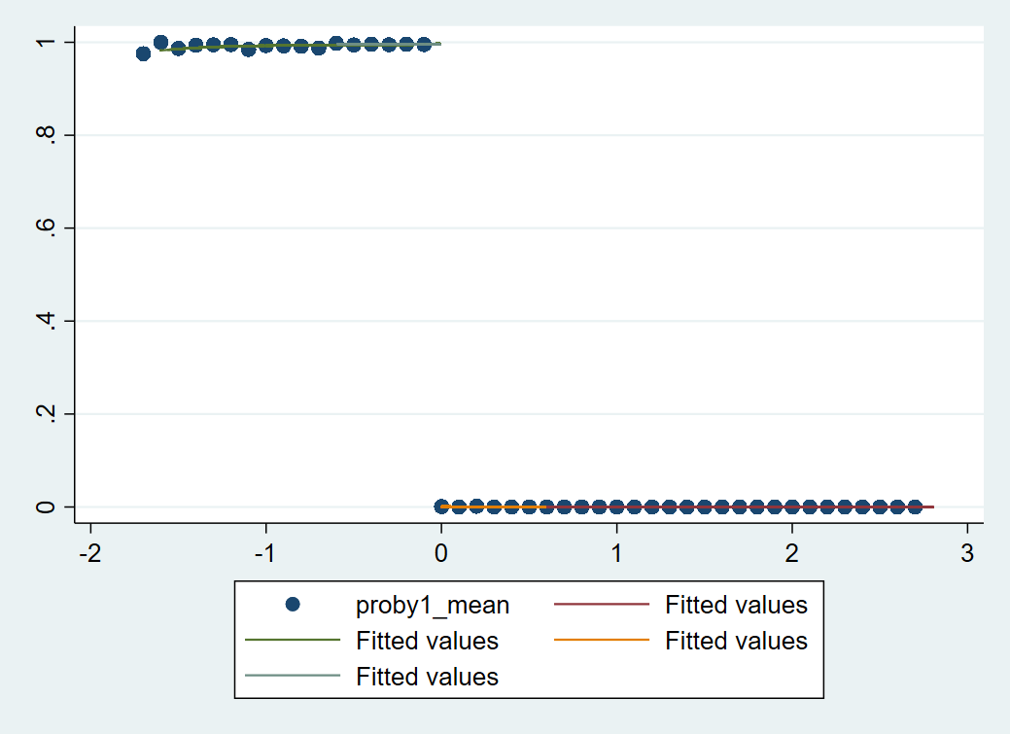

Graph 3 plots the local mean of probation ever and the polynomial fir against the running variable

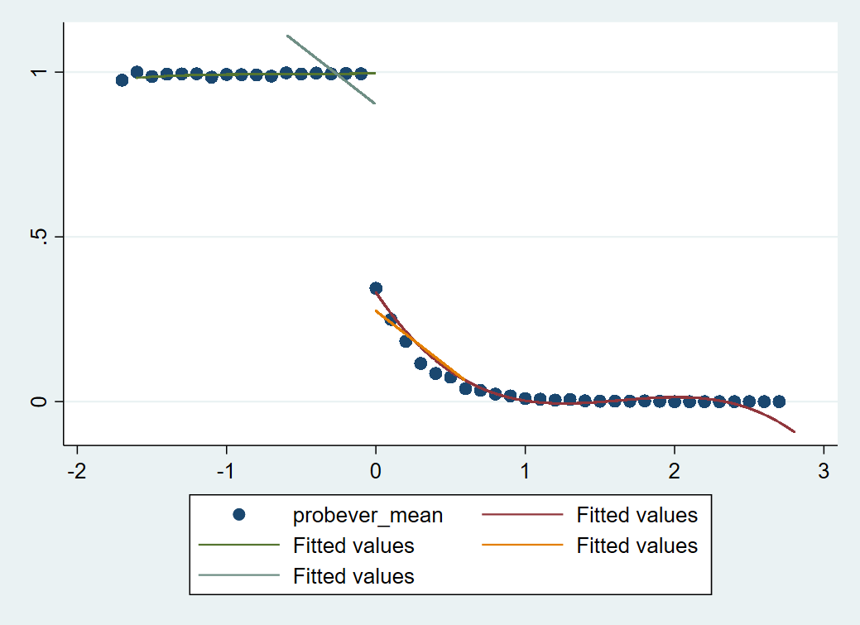

Graph 2 is basically a graphical representation of table 1. Where there is almost a zero probability of being on academic probation first year if the student is above the cutoff and almost a 100% probability of being on academic probation first year if the student is below the cutoff. Graph 3 is basically a graphical representation of table 2. As students get closer to the cutoff, their probability of being on academic probation ever increases.

5. Table 3 shows local regression of next GPA on our dummy, distance from cutoff, and interaction variables



Table 4 shows local regression of dropping out on our dummy, distance from cutoff, and interaction variables



It is not reasonable to interpret the discontinuity in dropout rates as the effect of actually being placed on probation after the first year since we are using a local linear probability model and not a probit or logit which could assess the association between the two more accurately. Also, there are unobservables that could affect both the dropout rate and being on probation which are not included in the regression. The polynomial regression also has an insignificant value for the binary variable when regressed on dropout rates.

The estimated effect on second year GPA is biased since there are students being dropped from the dataset since they are actually dropping out because of bad grades or students with great grades transfer to better schools. The change in the dataset year to year would bias the estimate on the binary variable.

6. Being above or below the mean of your high school class has no significant effect of graduating in 4 years. Being above the mean of your high school class has a significant positive effect at the 5% level of graduating in 5 years. Being above the mean of your high school class has a highly significant positive effect at the 1% level on graduating in 6 years.

7. Table 2 from question 3 shows that the cutoff binary variable is a good instrument for being on probation ever. The results from the two-stage least squares a line with that of question 6. The effect of ever being on probation still does not an effect on graduating in 4 years. It has a significant negative effect for graduating in 5 years but is not insignificant at 6 years using the local linear regression. Using the polynomial regression, ever being on probation still has a significant negative effect on graduating in 6 years. These are difficult to compare since question 6 is relating good high school performance with graduation probability and in this question, we are comparing bad college performance with graduation probability.